**Lab 02 Task**



**Name Hammad Arshad**

**Roll no SU92-BSAIM-F23-030**

**Section BSAI-4A**

**Subject PAI (LAB)**

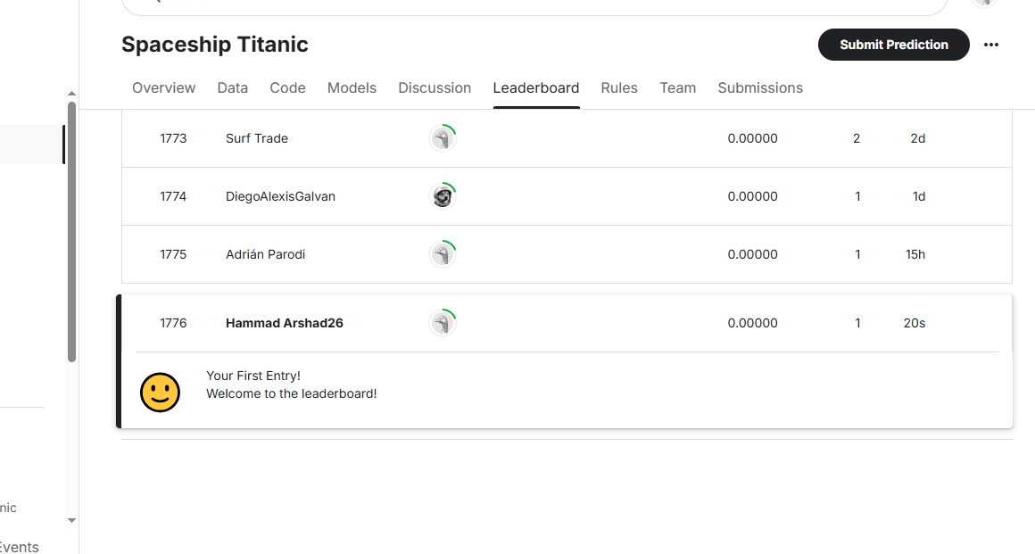

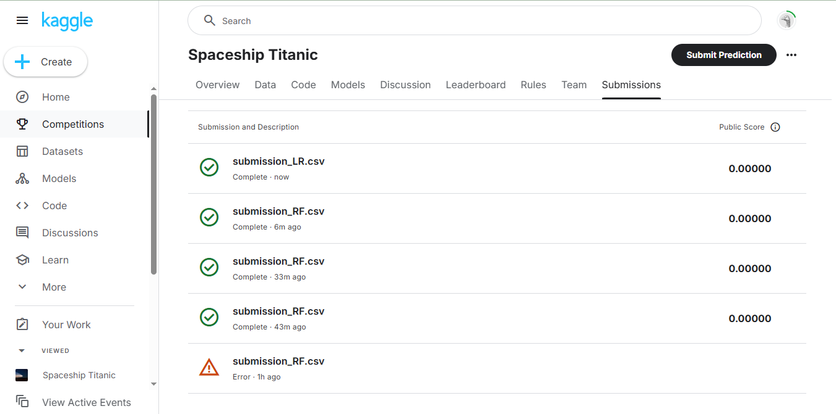

I applied Linear Regression and Random Forest models to the dataset, but the score remained 0.0000 every time.

At first, I experimented with different ways to process the dataset, such as handling missing values and adjusting features, but there was no change in the score. After trying multiple preprocessing approaches, I decided to change the model, thinking it might improve the result. However, even after switching models, the score remained exactly the same.

This suggests that the predictions are being generated, but they aren’t affecting the final evaluation on Kaggle. It could be due to how the competition processes the submissions, how the dataset is structured, or something specific about how the model's output is formatted for submission.